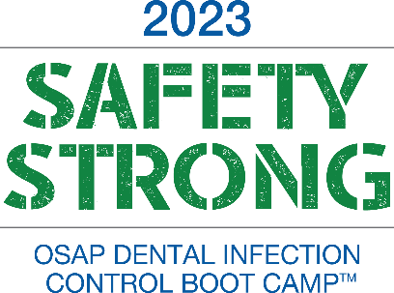
Dear <Supervisor’s Name>:
I would like to register for the On-Demand Only version of the 2023 OSAP Dental Infection Control Boot Camp™ (“Boot Camp”).
Boot Camp is a fast-paced, foundational-level educational course presented by national and international experts in dental infection prevention and patient safety. The course curriculum is based on the CDC Guidelines for Infection Control in Dental Health-Care Settings-2003, the 2016 Summary of Infection Prevention Practices in Dental Settings: Basic Expectations for Safe Care, and OSHA Bloodborne Pathogens Standard (1910.1030). This year, due to the continued COVID-19 pandemic, course content will also cover interim guidance and any related regulations.
The in-person event took place January 23 – 25 in Atlanta, GA. All event sessions were recorded. I will receive my on-demand access to the recordings immediately upon registration, and I will have access until Friday, May 12.
Registration provides me with:

- Access to 20+ hours of on-demand session recordings for 60 days
- One digital copy of OSHA & CDC Guidelines: OSAP Interact Training System – 7th Edition workbook
- Access to PowerPoints, checklists, tools, and resources
- Digital badge and online certificate of attendance
- 20+ hours of ADA CERP self-study CE
After reviewing the course materials, I have identified several educational sessions that will allow me to gain knowledge and understanding about how we can improve our internal processes related to patient and provider infection control and safety. The presentations are facilitated by scientific experts and oral health colleagues who have faced similar challenges and are directly applicable to my work. I specifically chose these presentations because they directly relate to <insert issue your facility is currently dealing with>.
- <insert the session title and description>
- <insert the session title and description >
- <insert the session title and description >

I am seeking financial support for the registration fee ($689 (OSAP Member)/$889 (Non-Member). Since I will access the sessions online, there are no additional expenses for travel, accommodations, or food, making this a cost-effective educational experience.
The opportunity for me to gain knowledge in specific areas of my job makes my registration a wise investment. Please consider my participation. I’ll be glad to provide any additional information that you need to make a sound decision.
Sincerely,
<your name>

